Google classroom information for January lockdown 2021

Google Classroom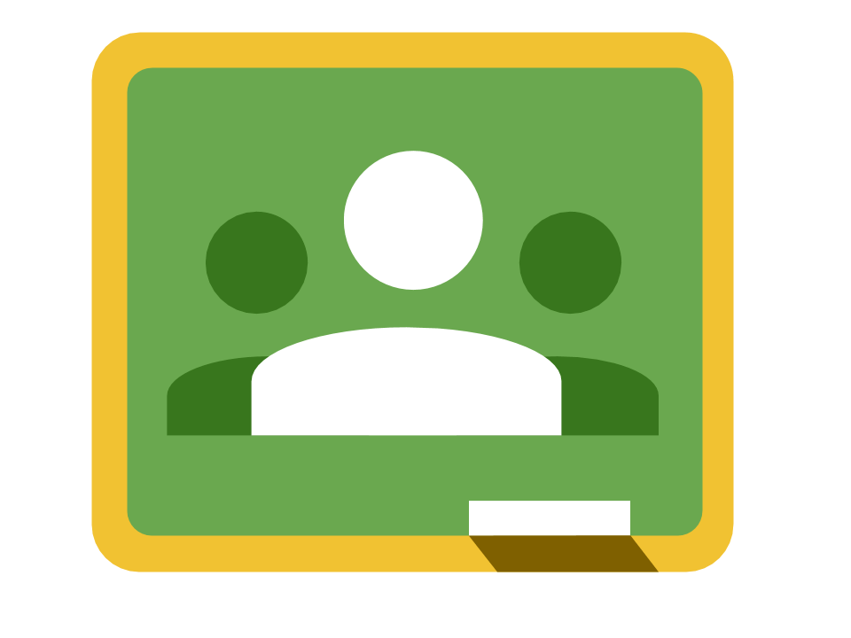 | How to Join and Create a Google Classroom in 2020!
 | How to Submit Assignments in Google Classroom
 | How To Turn Off Notifications in Google Classroom
 | How To Stay Organized in Google Classroom
 | Parents Guide to Google Classroom in 2020
 | Parent’s Guide to Student Email Summary in Google Classroom
 | How to Ask Your Teacher a Private Question in Google Classroom
 | How to Upload a Photo to Google Classroom Assignments
 | How to Watch YouTube Videos in Safe Mode - No Ads or Recommended Videos

Google Jamboard | Guide to Google Jamboard for Beginners
 | Top 5 Jamboard Features

Google Docs  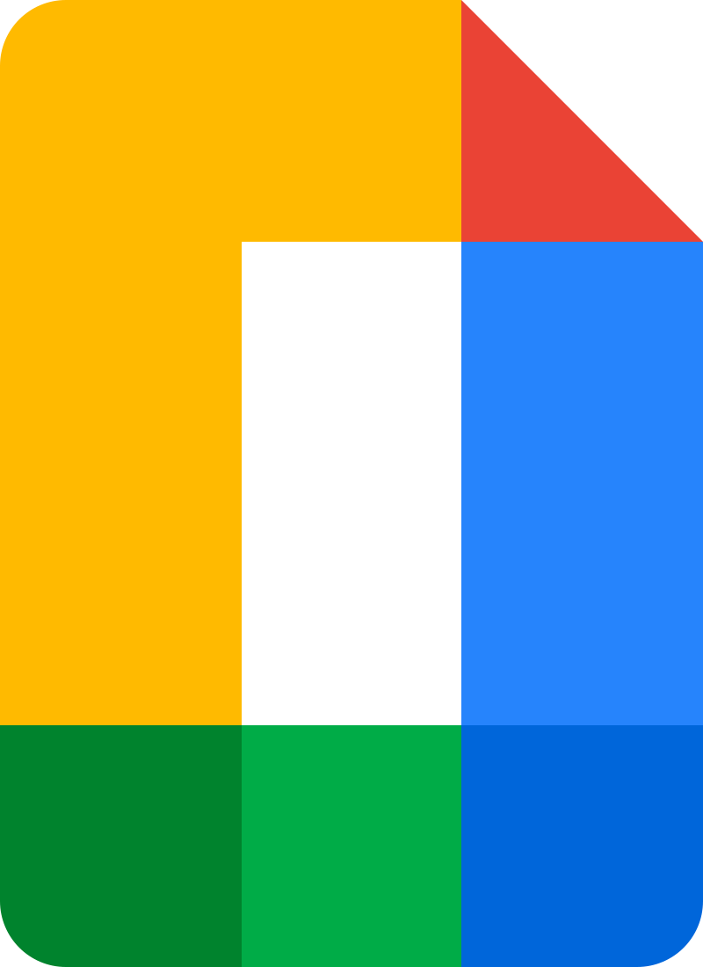 | How to Create and Edit Tables/Charts
 | How to Make Automatic Copies for Students to Edit

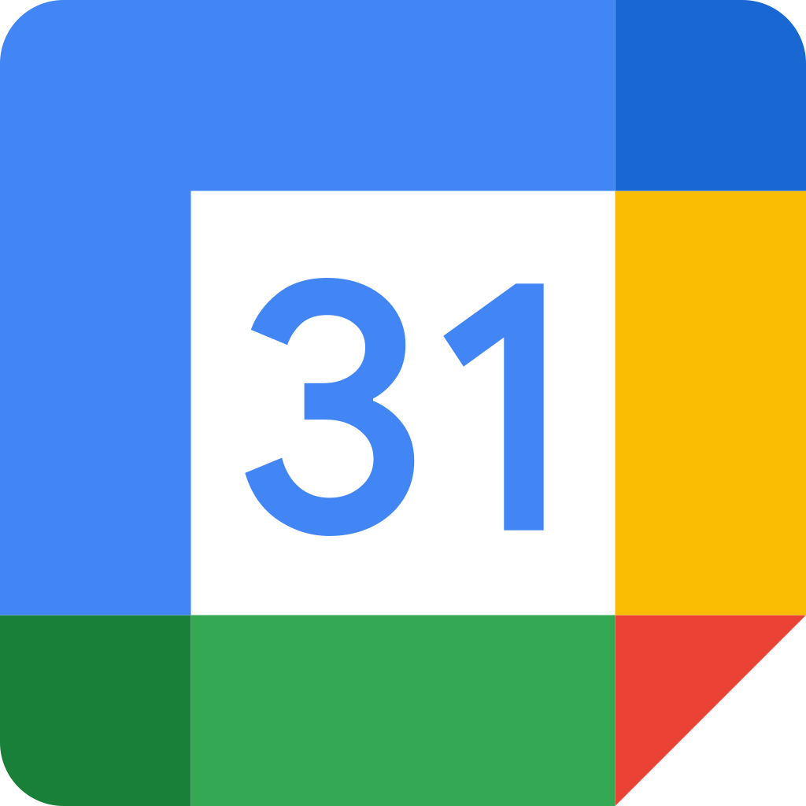  Google Calendar | How To Schedule a Google Meet Using Google Calendar
 | How to Find the Recording of A Google Hangouts Meet
 | How to Find When Your Google Assignment are Due
 | How to Create Appointment Slots

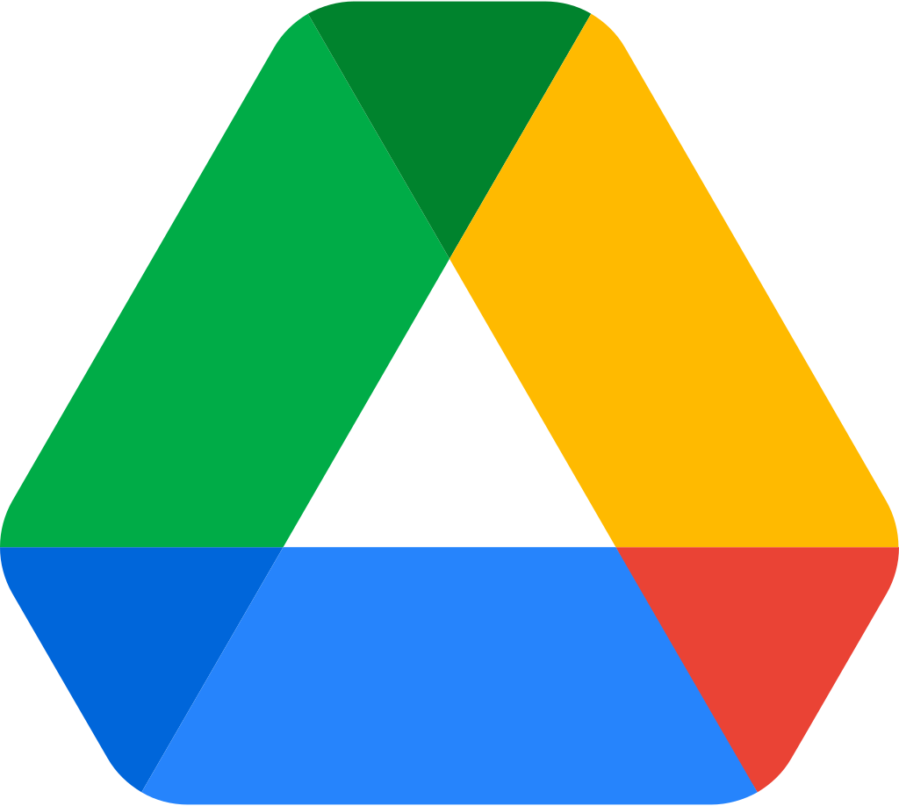  Google Drive: | How to Find Shared Docs, Files and Folders in Google Drive

Google Chat | Guide to Google Chat

Google Sites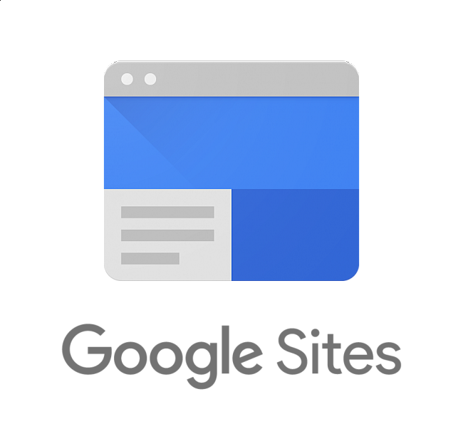 | Guide to Google Sites in 2020

